# CS 255 System Design Document Template

This template lays out all the different sections that you need to complete for Project Two. Each section has guidance to prompt your thinking. You will need to continually reference the interview transcript as you work to make sure that you are addressing your client’s needs. There is no required length for the final document. Instead the goal is to complete each section based on what your client’s needs are. Remove this note when you are finished, and replace all bracketed text with the relevant information.

## UML Diagrams

### UML Use Case Diagram

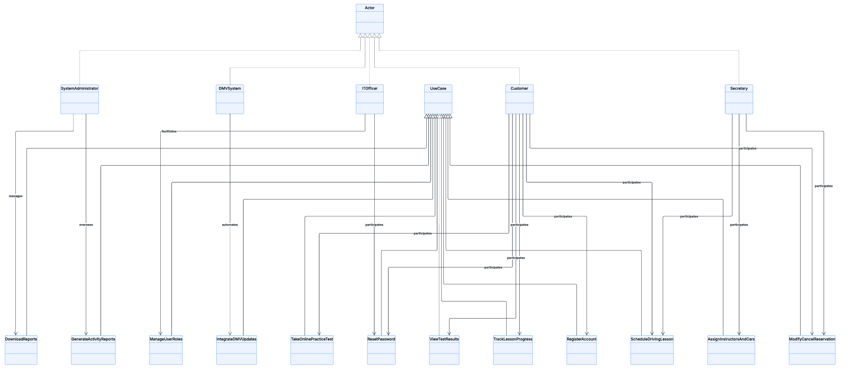

### UML Activity Diagrams

**Activity Diagram 1: Scheduling a Lesson**

*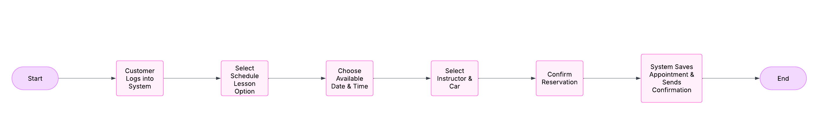***Activity Diagram 2: Taking an Online Test**



### UML Sequence Diagram

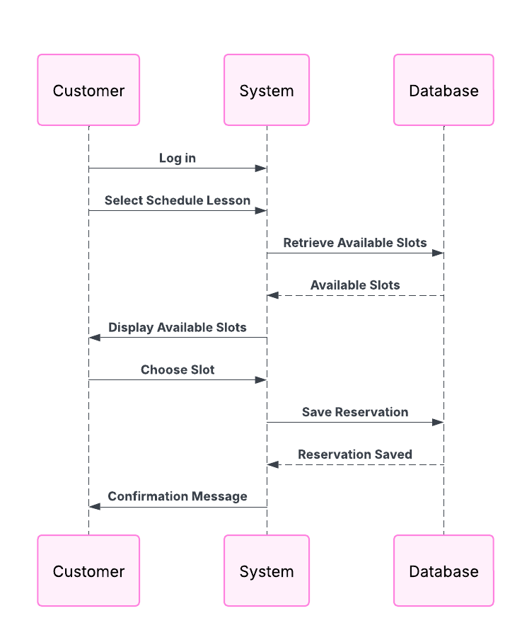

### UML Class Diagram

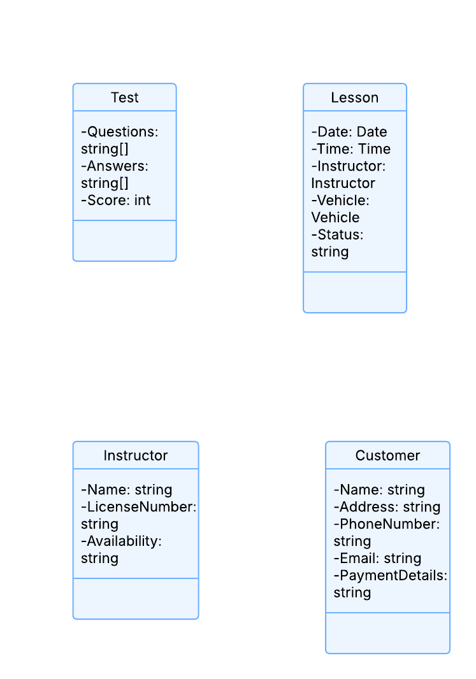

## Technical Requirements

Hardware Requirements:

* Web server with cloud-based hosting
* Minimum 8GB RAM, Quad-Core Processor
* Secure storage for database access

Software Requirements:

* Web-based application using HTML, CSS, JavaScript
* Backend developed using Python (Django) or Java (Spring Boot)
* Database: MySQL or PostgreSQL
* Security: SSL Encryption, Role-based Access Control

Tools & Infrastructure:

* Lucidchart for UML diagrams
* GitHub for version control
* AWS or Azure cloud services for hosting
* Automated backup & disaster recovery setup